Part 1: Prepare the project
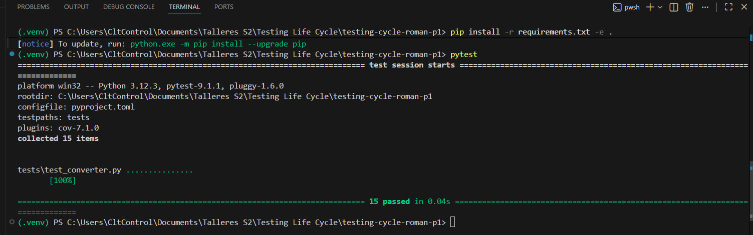
Part 2: Audit the inherited suite
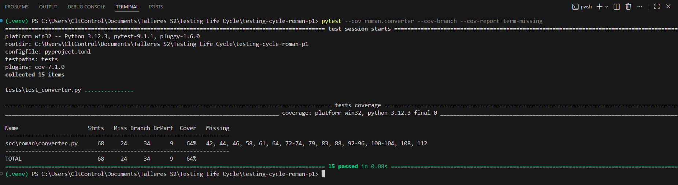
Part 3: Test at the unit level
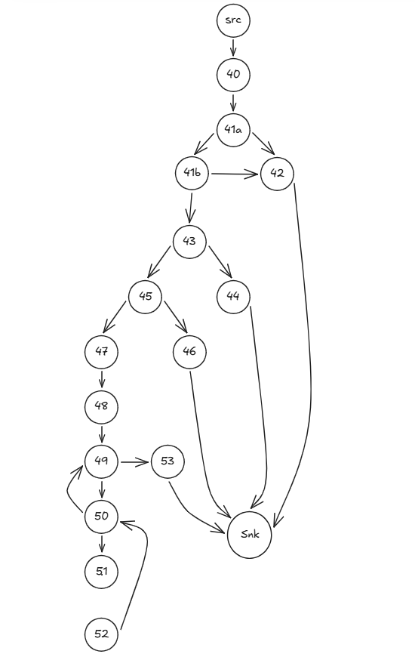
$$V(g) = E – N + 2 = 22 – 17 + 2 = 7$$
# | Camino | Decisión invertida | Entrada
P1 | src,40,41a,41b,43,45,47,48,49,53,snk | baseline | (infactible)
P2 | src,40,41a,42,snk | 41a | "X"
P3 | src,40,41a,41b,42,snk | 41b | True
P4 | src,40,41a,41b,43,44,snk | 43 | 0
P5 | src,40,41a,41b,43,45,46,snk | 45 | 4000
P6 | src,40,41a,41b,43,45,47,48,49,50,49,53,snk | 49 | (infactible)
P7 | src,40,41a,41b,43,45,47,48,49,50,51,52,50,49,53,snk | 50 | 1

